**Chapter 1**

**The Amazing World of TensorFlow**

By 2025, the world will generate more than five million gigabytes of data every second. Every search query, photo, and voice command contributes to this explosion. But data on its own is not useful—it only becomes valuable when transformed into insights. Machine learning, and especially deep learning, provides the bridge between raw data and information. Modern deep learning models, with millions or even billions of parameters, demand efficient frameworks and powerful hardware. This is where TensorFlow comes in.

TensorFlow, developed by Google, is an end-to-end machine learning framework that manages nearly every stage of the ML lifecycle: prototyping, model building, training, monitoring, and deployment. Its ecosystem includes the tf.data API for constructing efficient pipelines, Keras for high-level model creation, TensorBoard for real-time visualization, TensorFlow Hub for accessing pretrained models, and TensorFlow Serving for production deployment. Together, these components make TensorFlow versatile enough to support both quick experimentation and large-scale production systems.

Building a model with TensorFlow typically follows a well-known process: starting with data exploration and cleaning, followed by feature engineering, model training, and evaluation, and ending with deployment. Monitoring is a key step, where tools such as TensorBoard help visualize metrics like accuracy and loss during training. Once trained, models can be saved in HDF5 format or the standardized SavedModel format, and then deployed as APIs with TensorFlow Serving.

The choice of hardware plays a critical role. CPUs are like cars—designed for low-latency tasks at a small scale. GPUs, by contrast, act like buses—slower per passenger, but able to move many in parallel, making them ideal for deep learning’s heavy use of matrix multiplications. Google’s TPUs are specialized buses, stripped down for efficiency, designed specifically for machine learning workloads (see Fig. 1).

Figure 1 Comparison of CPU, GPU, and TPU architectures. The CPU is like a car, optimized for fast, small-scale tasks; the GPU is like a bus, designed for high-throughput parallel work; and the TPU is a specialized bus, efficient only in specific machine learning

TensorFlow is powerful, but it is not a universal solution. It shines in prototyping deep neural networks, leveraging GPUs and TPUs, serving models in the cloud, monitoring training performance, and handling massive data pipelines. However, it is less suited for traditional ML algorithms (like decision trees), for small structured datasets that fit easily in memory, or for complex text preprocessing pipelines. In such cases, libraries like scikit-learn, NumPy, pandas, or spaCy are often better choices.

Table 1 Summary of TensorFlow benefits and drawbacks

|  |  |  |
| --- | --- | --- |
| Task | Yes | No |
| Prototyping deep learning models | ✅ |  |
| Running models faster on optimized hardware (GPU/TPU) | ✅ |  |
| Productionizing models / serving on cloud | ✅ |  |
| Monitoring models during training | ✅ |  |
| Creating heavy-duty data pipelines | ✅ |  |
| Implementing traditional ML models (e.g., SVM, k-means) |  | ❎ |
| Manipulating/analyzing small structured datasets |  | ❎ |
| Building complex NLP preprocessing pipelines |  | ❎ |

The chapter also emphasizes why this book is built around Python and TensorFlow 2. Python has become the dominant language in scientific computing, thanks to its extensive ecosystem of libraries. TensorFlow, meanwhile, has matured into a stable, production-ready framework that offers breadth beyond most competitors. Figures in this chapter underscore these points: Fig. 2 shows Python’s rise in popularity, Fig. 3 compares the adoption of TensorFlow and PyTorch, and Fig. 4 highlights TensorFlow’s performance advantage over NumPy in large-scale matrix calculations.

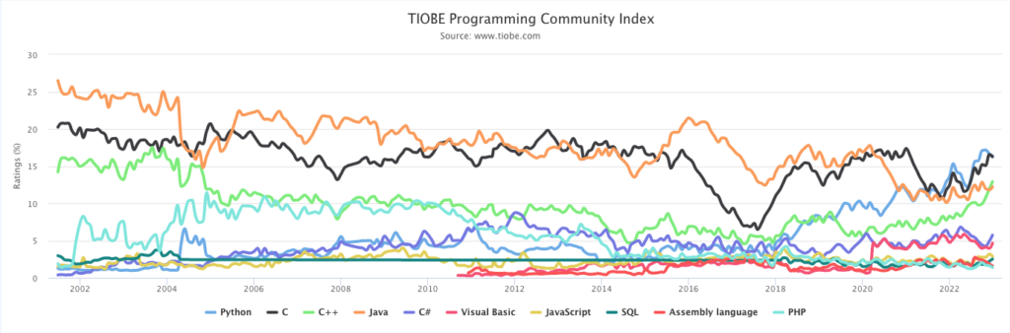

Figure 2 Popularity of different programming languages (2002-2022)

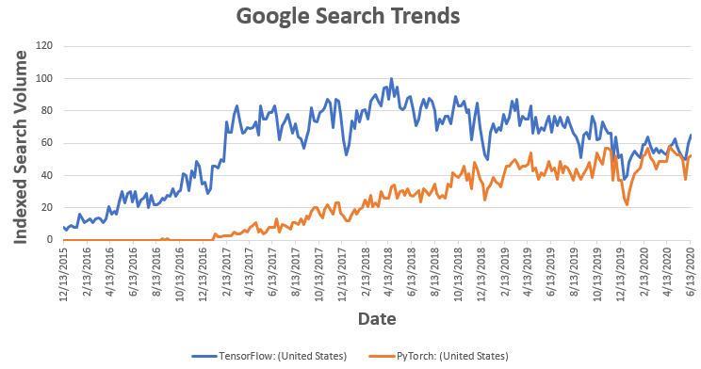

Figure 3 Popularity of TensorFlow and PyTorch (2015-2020)

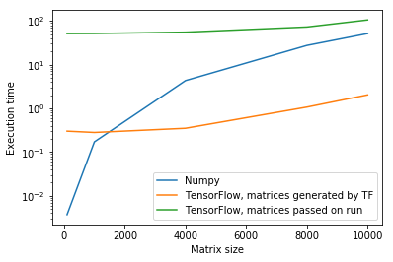

Figure 4 Comparing NumPy and TensorFlow computing libraries in a matrix calculations

In summary, deep learning thrives in the presence of large data, and TensorFlow enables this scale by combining ease of prototyping with robust production tools. Although not the best choice for small datasets or traditional ML, it is unmatched when training and deploying modern neural networks. This book’s goal is not merely to show how to write TensorFlow code, but to teach how to build effective TensorFlow solutions.